IGNITING “IGNATIAN VALUES” IN THE MINDS AND HEARTS OF THE YOUNG ROSARITES
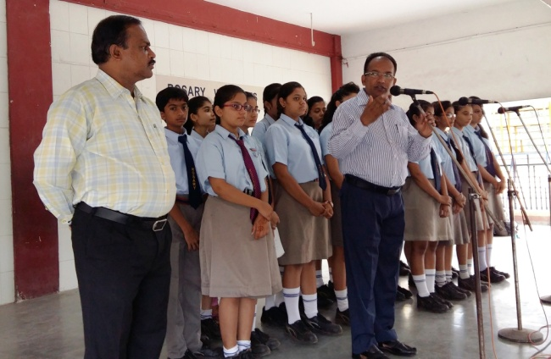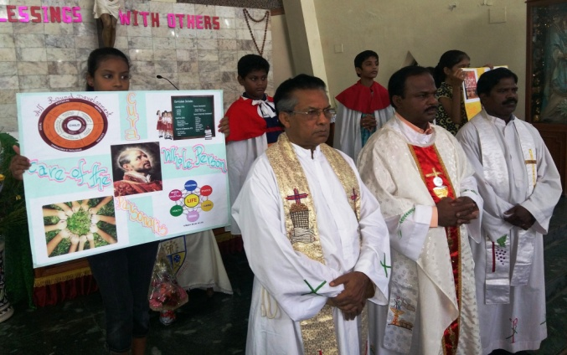

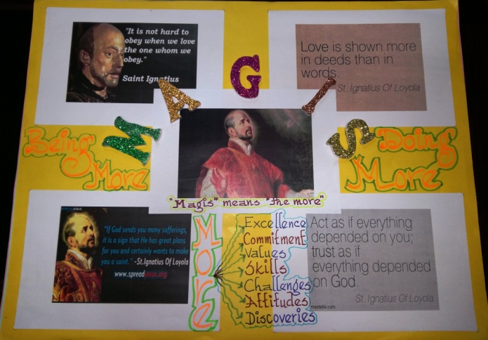
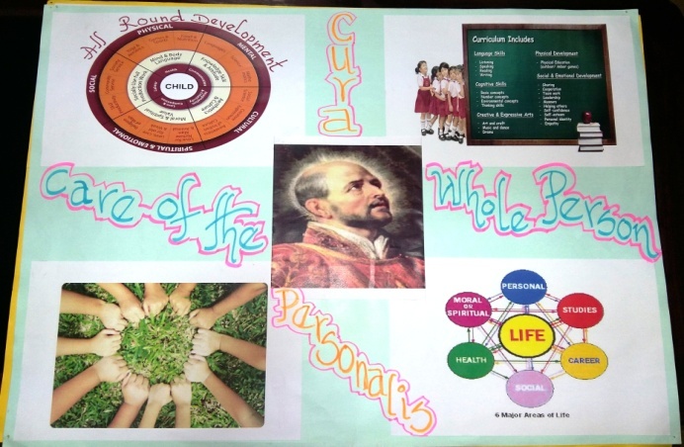
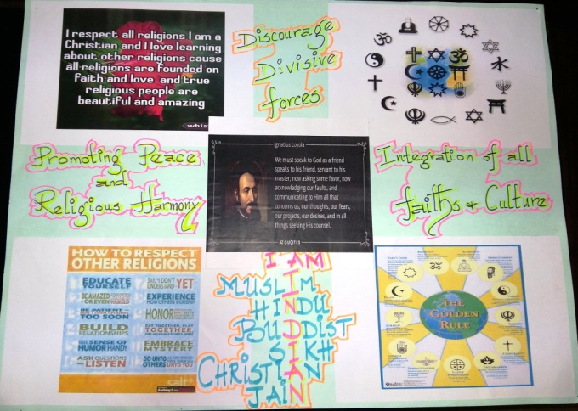
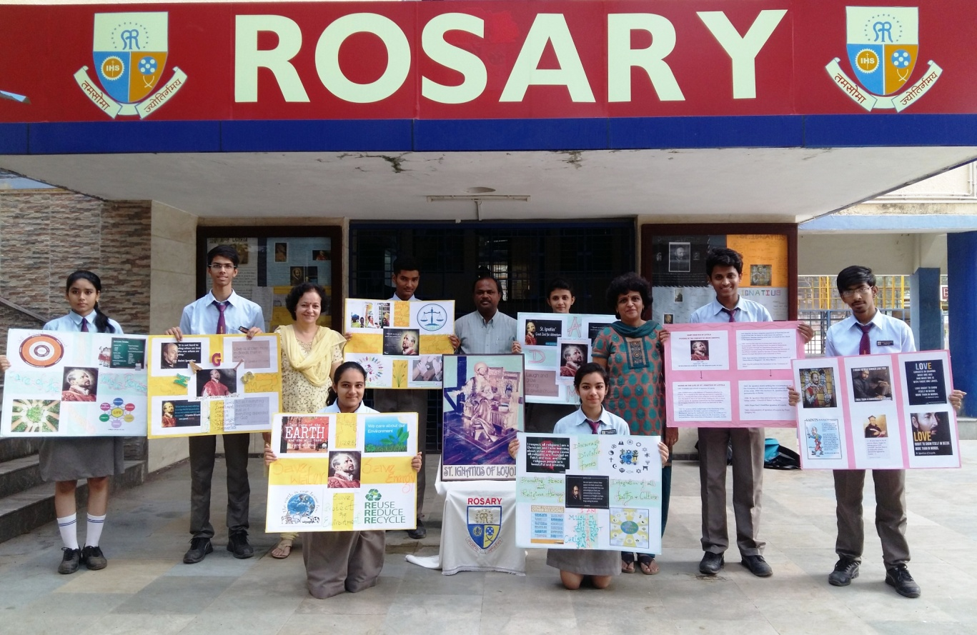
This year, Rosary High School, Baroda, Gujarat, had a very meaningful celebration of St. Ignatius’ feast. The management, the staff and the students were very much involved in the preparation for the feast. The themes sent by our JEA secretary (South Asia), Fr. Sunny Jacob, were taken for the assembly every day. Different staff members were selected, guided and assigned for each day to conduct prayer and to provide reflections to the students. All of them did a wonderful job with an able guidance of Fr. Lucas Rayapppan, the Principal of the school. On the very first day, Fr. Lucas Rayappan, the Principal of the school began the Ignatian Week with a prayer session by stressing on the four pillars of Jesuit Education. That is (SIPS) 1. Spiritual Dimension 2. Intellectual Dimension 3. Personal Dimension and 4. Social Dimension. Wonderful charts were prepared with the help of the students, meaningful stories were narrated and examples were given aptly to explain various themes such as Magis, Finding God in all things, AMDG, Cura Personalis, Promoting Faith and Justice, Care for the Environment and mother Earth, and Respect for other Religions. And on the last day, once again Fr. Lucas, the Principal of the School summed it up so beautifully summarizing all the themes giving the gist of Ignatian Spirituality and what Jesuit Education means today.
On the feast day of our founder St. Ignatius, we had solemn Mass for the catholic students, staff and the parents. The liturgy was filled with lot of creativity and devotion. This was followed by cultural programmes in the school assembly hall for two hours. The staff and the students felicitated the fathers and finally ended the day with a delicious meal with the staff members. It was a wonderful celebration indeed.
As a culmination, Fr. Sunny Jacob, our JEA secretary (South Asia), visited our school on the 3rd of August and addressed the students and the staff. In his address he stressed on the 5 C’s of Jesuit Education and Ignatian values. 1). Conscience 2). Competence 3). Commitment 4). Compassion and 5) Character. What a wonderful Ignatian Week we had in Rosary! May our founder St. Ignatius continue to inspire us to inculcate the values of Ignatian Spirituality in the hearts and minds of our young in our Apostolate. Amen. (Fr. Rayappan Irudayam)

