SEMINAR ON SECONDARY EDUCATION
September 19TH -20TH
KARNATAKA PROVINCE
VENUE: ST. JOSEPH’S BOYS’ HIGH SCHOOL AUDITORIUM , BANGALORE.
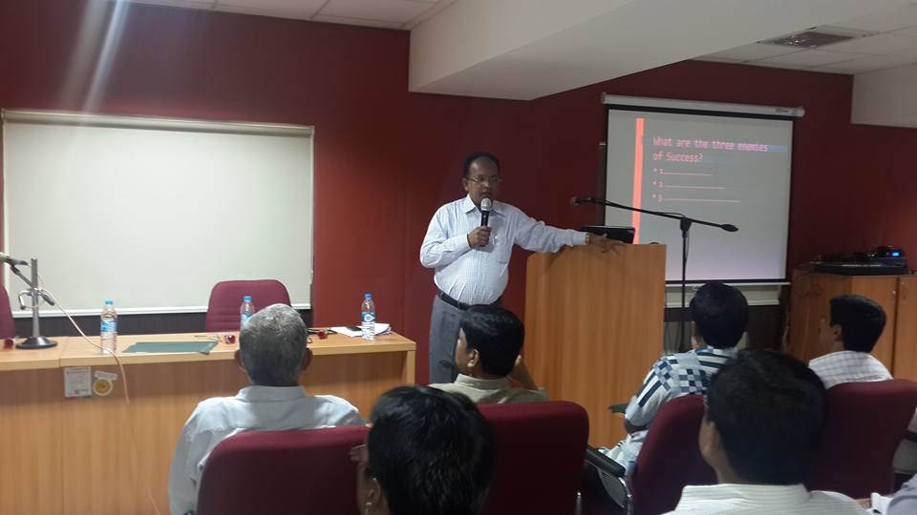
“A teacher affects eternity, he/she can never tell where his influence stops.” says a great sage. It was an enriching experience for me to attend the seminar on “Secondary Education” conducted by Fr. Sunny Jacob S.J., Secretary, Jesuit Educational Association, South Asia (JEA) and arranged by Fr. Henry Saldanha S.J., Province Co-ordinator for Secondary Education (PCSE). There were 135 participants of which 23 were Jesuits including the resource persons, 3 religious nuns, 45 women and 65 men.
We began our two days seminar at 9.15am with the lighting of the lamp followed by a meaningful prayer service. Fr. Henry Saldanha S.J. (PCSE) welcomed the gathering and briefed us about the seminar. In the inaugural address Fr. Leo Pereira S.J. (Provincial delegate) spoke on the importance of teachers and said-
“READ SOMETHING THAT NO ONE ELSE IS READING,
THINK SOMETHING THAT NO ONE ELSE IS THINKING,
DO SOMETHING THAT NO ONE ELSE IS DOING.”
Fr. Eugene Lobo S.J., Secretary for Karnataka Regional Commission for Education, gave us the inputs on Catholic Education Today. “Catholic Education is one of the greatest challenges for the Church, which is committed to carrying out the New Evangelization, in a historic and cultural context that is in constant transformation”, says Pope Francis. He proposed three aspects: dialogue in education, preparation of formators and living presence of the Gospel in the fields of education, science and culture. He also said that Jesuit education takes the whole person into account and fosters not only intellectual development, but also moral and spiritual growth.
Fr. Sunny Jacob S.J. with his great expertise spoke on “Challenges and Opportunities for Jesuit Education Today”, i.e. in the modern world it’s not easy to be a teacher but we too should upgrade our-selves according to the changing times. First of all the teacher should have a smiling face and do his or her duty with love. We are a living example for the students to follow; because the students more than listening to us they see us and imitate us. As we know our 85% non –verbal communication is more effective than the 15% verbal communication. In his talk on New Education Policy and our Response, he said that we should be aware of all the amendments which have been done regarding education ; and we instead of criticizing first we should give our suggestions. These were the highlights of the Suggestions submitted to the Ministry of Human Resources (MHRD, Government of INDIA):
. Providing Quality and holistic education for all.
. Accountability and responsibility in education structure.
. Give autonomy to Schools; allow more autonomous education boards by those who have been in the forefront in Education.
. Value Education and probity in Public life without going religion specific.
. Amend RTE Act to provide education for 0 to 14 of age, and all promotion till class 3.
. Diversity, Inclusiveness and Constitutional values to be upheld.
. Divergent and critical thinking has to encouraged than convergent thinking.
. Make Teachers training and updating mandatory as we prepare people for Civil Service. Teaching is also an important Civil Service.
. Promote Constitutional Values; Rights and Duties of citizens in education.
. Prepare the young towards nation building and national integration, by developing leadership skills, Technical skills, social service skills and qualities of the heart.
. Teach students to be eco- sensitive leaders for the Nation.
Fr. Sunny also spoke that our education should be empowering and inclusive. This should be child oriented. Their safety and growth for all round development should be our main focus. He dealt with the importance of Child protection Policy in all our schools. He explained what is child abuse, and made us understand about the neglect, physical abuse, sexual abuse and mental or emotional abuse. It was a very enlightening class for all of us.
Fr. Sunny met the Jesuits separately in a meeting and explained them about the national and international challenges we face and ways to over come them.
On Sunday, we had group discussion in which the Jesuit collaborators (teachers) very beautifully expressed their happiness to belong to the large Jesuit family, where they learn to adapt to different types of people, places and situations. Some of the struggles were to teach the students good values in this consumerist modern world and bring them to a proper standard. All of us felt that we need to carry on the legacy of St. Ignatius of Loyola and all the Jesuits.
I am grateful to God who has blessed me and called me to be a teacher and I am also thankful to all the fathers who have contributed for this seminar. Let us all be these great gifted teachers who will reveal the simplicity to the students.
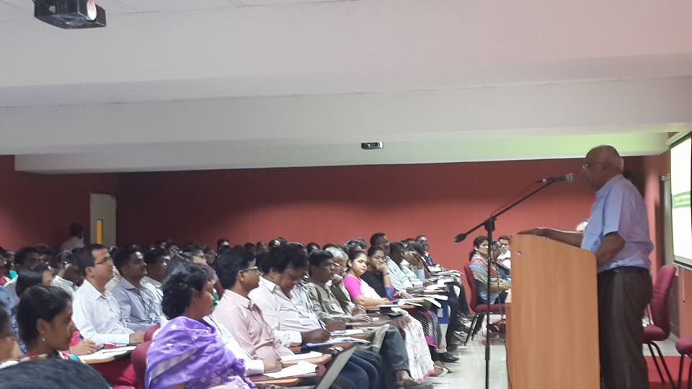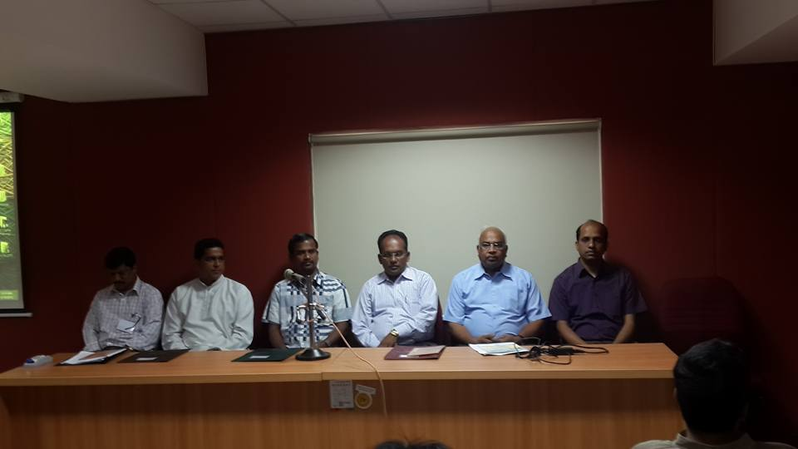

The meeting also discussed the ways of more Zonal level programmes for the teachers and principals. It also expressed POSA’s concern on Education for the South Asian Assistancy. We need to bring out a flagship programme for the South Asian Assistancy. Towards that we need to form an expert group to suggest new ideas to JEA. In our annual JEA meet in Darjeeling the PCEs will discuss about it seriously.
The meeting ended with a happy note. Everyone was so happy and revitalised. Thanks to Fr. Henry who organised a guided Bangalore tour for the first timers in Bangalore.
By Mrs. Maria J Pinto, Loyola PU College, Bangalore

