Fr. Alex Minj SJ, a great companion to all…
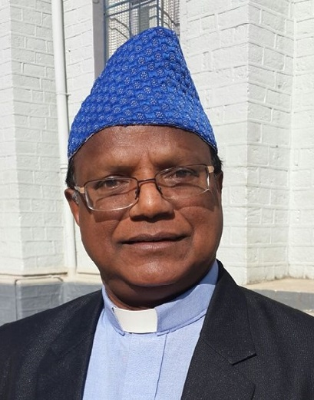

A year ago we decided to hold the Annual JEA Meet at Kathmandu, Nepal. But the devastating earthquake that shook Nepal, made me to change the venue of the JEA from Nepal to India. Fr.Alex Minj SJ, the coordinator of Darjeeling was my natural choice of consulting to decide the next venue. I called upto him and he immediately redied to welcome all the coordinators to his Province. After consulting the Zonal coordinator I decided to have it in Darjeeling. Then on Fr. Alex was a constant companion to me till his last breath on 16th November.
All my PCEs will agree that there could have been no better coordination and hospitality than that was provided this time by Alex. He saw to it that every PCE reach the place without any hustle. He called up all of them and arranged their conveyance to North Point without any difficulty to anyone. He arranged their stay etc….so comfortably. When arrived there I saw the list was ready and meticulously prepared programme on the notice board. He saw to it that our stay must be a memorable one. And we did. Our outing to Tiger Hills, or the marketing…or the lunch at a hotel etc were a sign that he went out of his way to help us all. The last day even the return journey he prepared such a way that all have a chance to visit our old Seminary at St. Mary’s Hill and a tea break at Kurseong. He was so energetic and enthusiastic, that one of the PCEs told me that Alex’s youthfulness is to be emulated by all!
However, I never thought that was my last day with him when on 15th November at 11a.m. he drove me to Bagdogra airport to leave me. On the way we stopped at Matigara Pastoral Centre and took lunch there. A jovial Alex even planned my next visit to Darjeeling schools in February.
While nearing the airport he told me there is still time so let us go for a ride….and on the way I saw a small church and a few children having some cultural programme. I mentioned about it and he told me that he was the founder of the church. He took me there and all of the gathered there came and wished him with immense affection and love. He was a great man of spirit. Whereever he went he transmitted enthusiasm to all. His smiling face….his energetic and sincere smile is contagious. After meeting all and eating there with people he took me to the airport. At the airport gate and bid farewell to me with a warm hug. He said that he was happy that everything went well and said my first meeting was a great success and wished me all the best. I never knew that was my last time to meet him……. After arriving at Delhi I send him a message of my safe arrival. He replied me, “praise the Lord! Meet you soon”….

It is with much shock and deep sorrow that I came to know the sudden demise of Fr Alex Minj SJ(1956-2015) , who passed away around 04.P.M. on 16th November in Kurseong. He was the Headmaster of St Alphonsus Higher Secondary School, Kurseong. Earlier he was the Headmaster of St Peter's Higher Secondary School, Gayaganga (2001-2013), Prefect of St Joseph's School, Darjeeling (North Point), Parish Priest of Catholic Church, Thandrabong, Kalimpong. .I have lost a good friend with is death, a great supporter of educational initiatives of the JEA, a contributor to the Website, above all a companion who stood with JEA during the last one year, whom I used to seek for guidance. May the all merciful Father grant him eternal rest and may his soul rest in peace. Miss you Alex……
Sunny Jacob SJ

