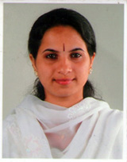
RAGNA G R

Ms. Ragna is a talented classical dance performer. She teaches at St. Josephs Boy’s school, Kozhikode, Kerala. JEA is happy to introduce her to all.

Ms. Ragna, G.R. a teacher of St. Joseph’s Boys’ H.S.S has a Diploma in Bharathanatyam from Kalakehetra foundation Chennai. In 2010 she completed her Master’s degree in Bharathanatyam from Bharathidiasan University, Trichy. As a team leader in dance troop she performed stage events in France, Spain, Dubai, Mauritus and Malaysia. Before joining St. Joseph’s Boys’ She worked as a team member of Kalashetra dance, drama troop and performed various stage events in different states in India. Her masterpiece is Ashtapadiyattam. She has done a Choreography for children’s play (PACHAPLAVILA)which bagged first place in state school kalolstasavm 2010- 11. She is a dance teacher since 2002. Apart from dance she loves music, reading and travelling. She speaks English, Hindi, Malyalam and Tamil. JEA wishes her all the best!
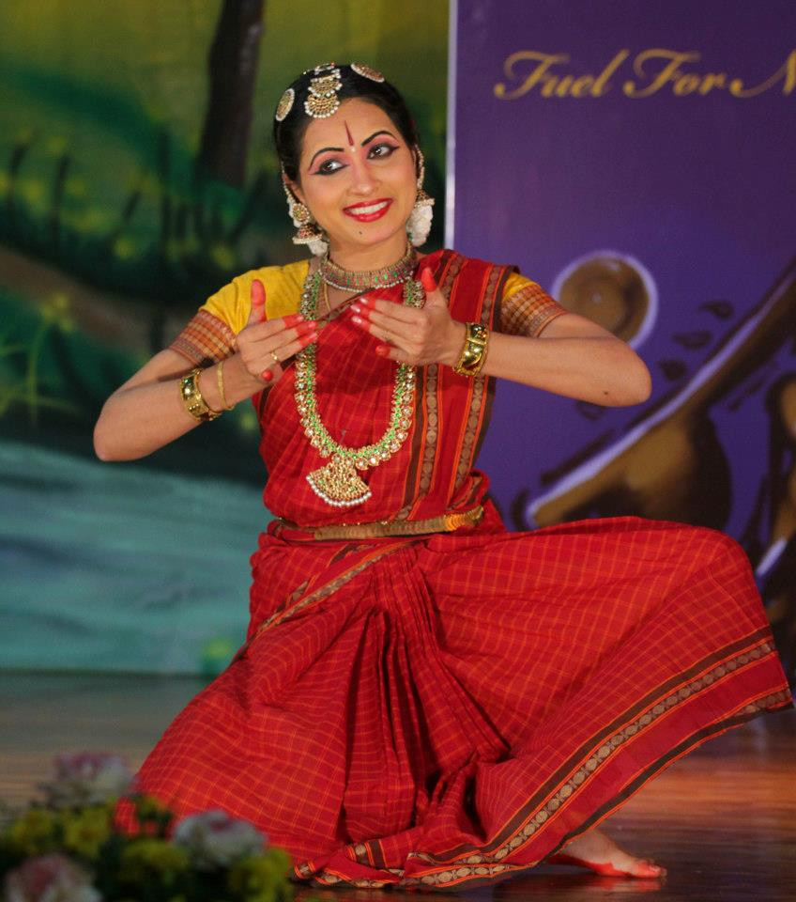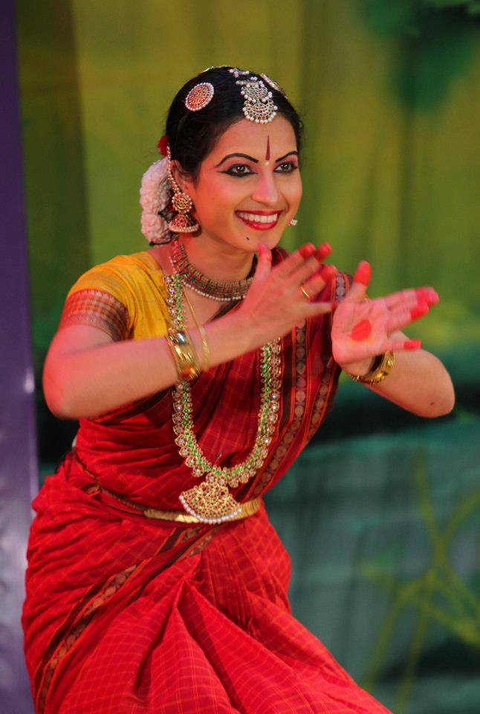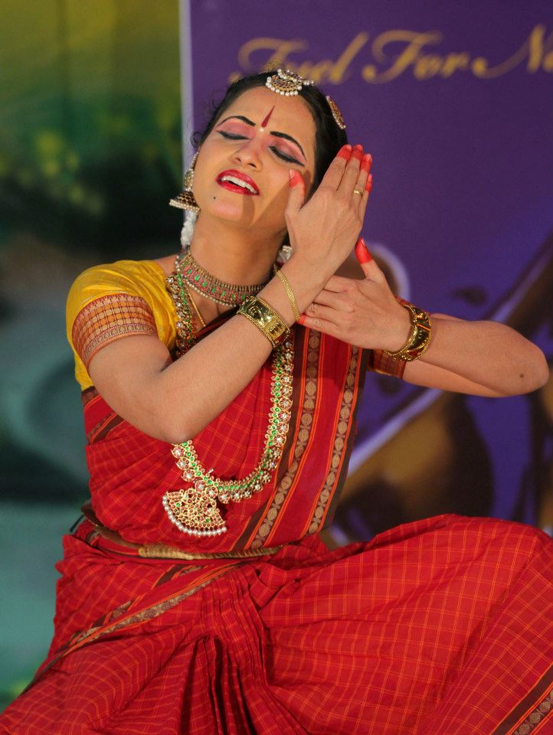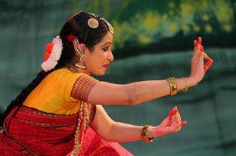
By Fr. Thadeyoos SJ, Coordinator of Kerala JEA

